| ***Create authentication service that returns JWT*** |
| --- |

Add appropriate dependencies to be loaded.

<dependencies>

<dependency>

<groupId>org.springframework.boot</groupId>

<artifactId>spring-boot-starter-security</artifactId>

</dependency>

<dependency>

<groupId>org.springframework.boot</groupId>

<artifactId>spring-boot-starter-web</artifactId>

</dependency>

<dependency>

<groupId>org.springframework.boot</groupId>

<artifactId>spring-boot-devtools</artifactId>

<scope>runtime</scope>

<optional>true</optional>

</dependency>

<dependency>

<groupId>org.springframework.boot</groupId>

<artifactId>spring-boot-starter-test</artifactId>

<scope>test</scope>

</dependency>

<dependency>

<groupId>org.springframework.security</groupId>

<artifactId>spring-security-test</artifactId>

<scope>test</scope>

</dependency>

</dependencies>

It is crucial to declare the spring boot version to be <= 2.6.6, because some modules of JWT are now depreceated.

Optional but specify a username and password inside application.properties.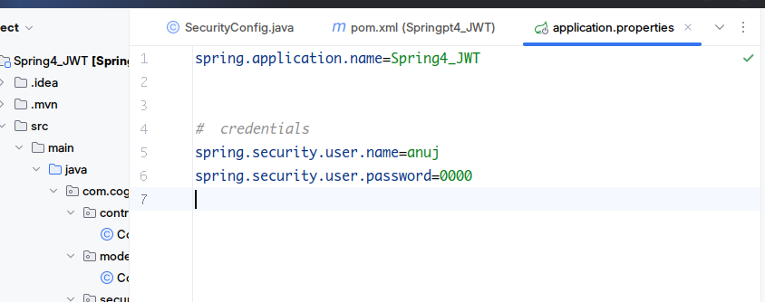

Configure the “Country.xml”

*<?*xml version="1.0" encoding="UTF-8"*?>*

<beans xmlns="http://www.springframework.org/schema/beans"

xmlns:xsi="http://www.w3.org/2001/XMLSchema-instance"

xsi:schemaLocation="http://www.springframework.org/schema/beans http://www.springframework.org/schema/beans/spring-beans.xsd">

<bean id="countryList" class="java.util.ArrayList">

<constructor-arg>

<list>

<bean class="com.cognizant.springpt4_jwt.model.Country">

<property name="code" value="IN"/>

<property name="name" value="India"/>

</bean>

<bean class="com.cognizant.springpt4_jwt.model.Country">

<property name="code" value="US"/>

<property name="name" value="United States"/>

</bean>

<bean class="com.cognizant.springpt4_jwt.model.Country">

<property name="code" value="JP"/>

<property name="name" value="Japan"/>

</bean>

<bean class="com.cognizant.springpt4_jwt.model.Country">

<property name="code" value="DE"/>

<property name="name" value="Germany"/>

</bean>

</list>

</constructor-arg>

</bean>

</beans>

Under the country controller class, create the mappings. 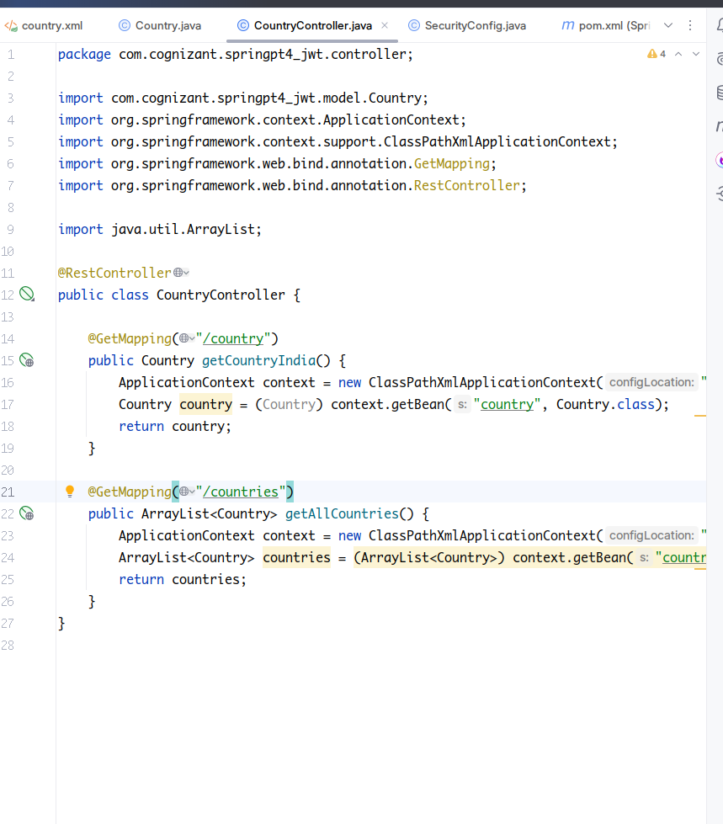

For now we have mappings, so our response would look like this :

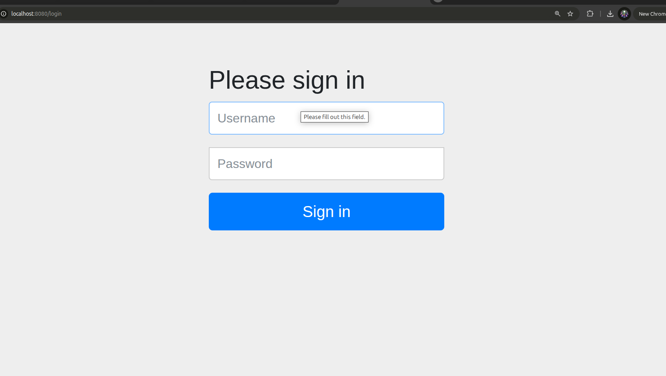

Create a new Package named security and a class named SecurityConfig extending WebSecurityConfigurerAdapter and override the configure(...) method.

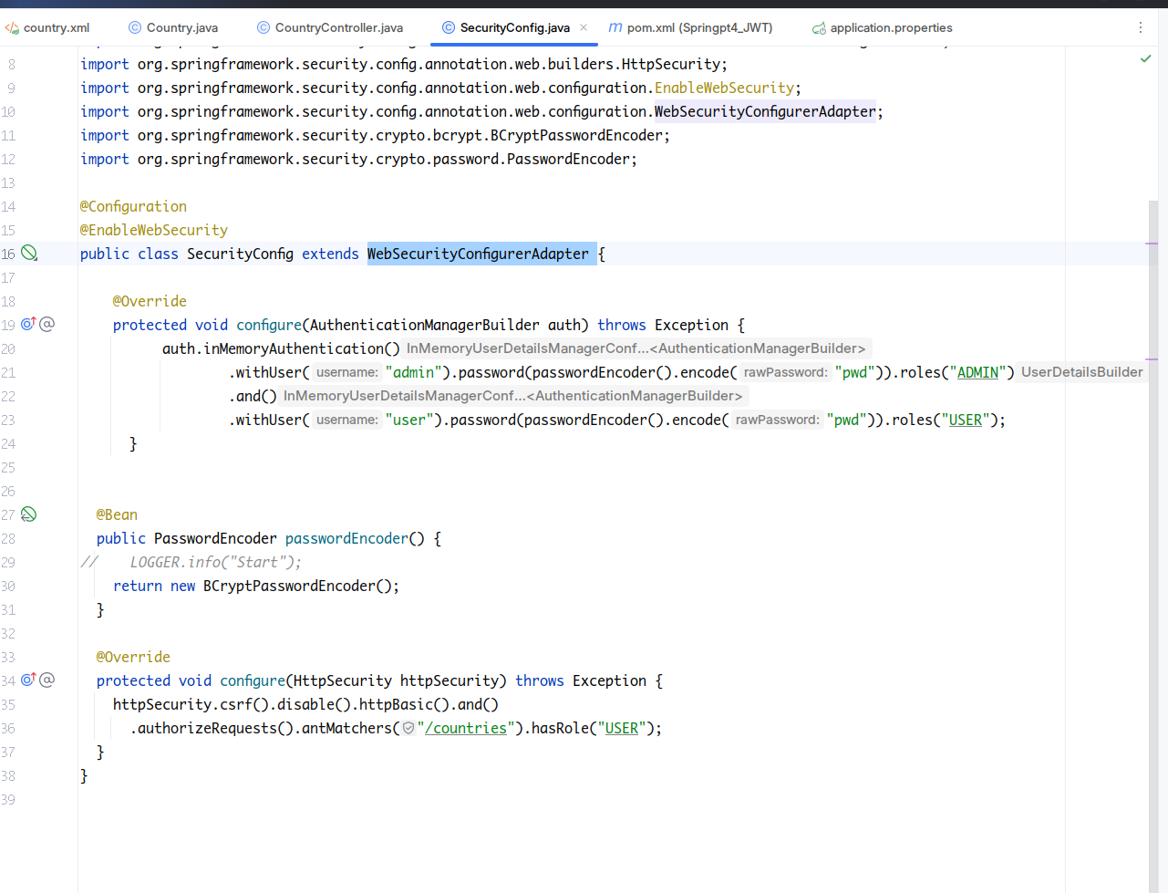

Its now time to test the security inside browser.

Go to the url. For me its localhost:8080. It will now ask for id and password.

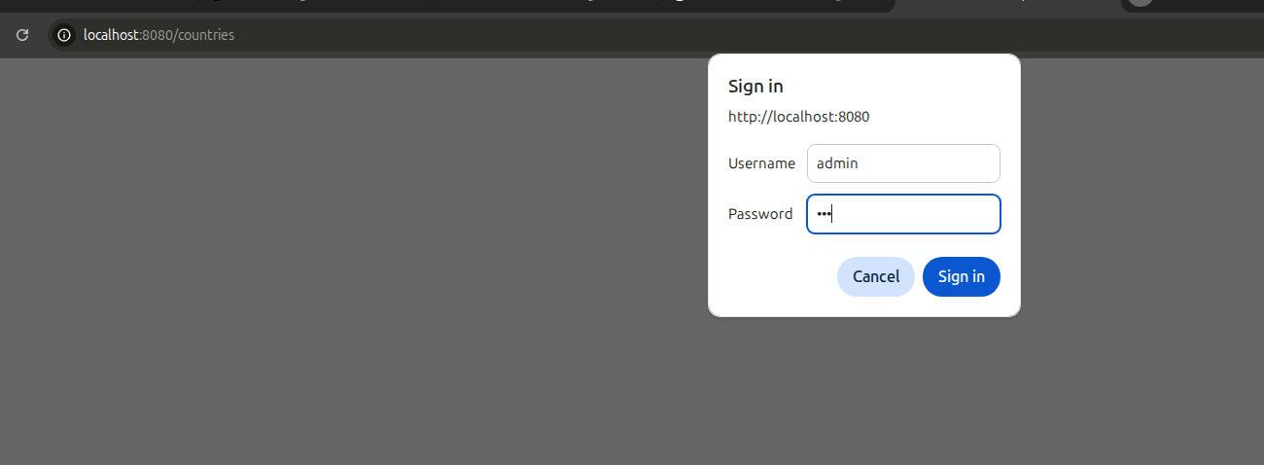

Since we have overridden the configure method, the application.properties message will be overridden with new one.